**5.6 Optional Assignment**

 Bookmark this page

**CLASSROOM ACTIVITY – PROBABILITY CALIBRATION**

We have a handout with 10 questions corresponding to uncertain quantities. Please provide a subjective 50% interval. That is, a lower bound and an upper bound so that for each of these, there's a 25% chance the true value is below the lower bound, a 25% chance the true value's above the upper bound, and a 50% chance that the true value's inside of your 50% interval. The values for the upper and lower bound are subjective and you need to guess the interval before the true values are known. There is no single answer to these intervals.

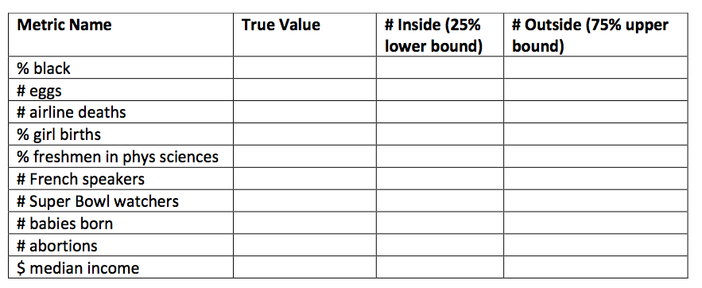

1. The percentage of people in the United States who are “black” (from the 1990 Census). 2. The total egg production in the United States in 1965 (in number of eggs).

3. The number of airline passengers worldwide who died in plane crashes in 1980.

4. The percentage of babies born in the United States that are girls.

5. The percentage of entering college freshmen in the United States in 1990whose probable field of study was physical sciences.

6. The number of native French speakers in Canada in 1981.

7. The number of people in the United States who watched the Super Bowl in 1995. 8. The number of babies born in the United States in 1992.

9. The number of abortions in the United States in 1992.

10. The median household income in the United States in 1996.

You can download the answer key from [here](https://prod-edxapp.edx-cdn.org/assets/courseware/v1/38b46f740d0b7fdd4c2438672c1b332c/asset-v1:ColumbiaX+DS101X+1T2017+type@asset+block/5.6_Calibration.pdf" \t "_blank).